Report of Head of Housing
To
Portfolio Holder for Safer Communities, Housing and Wellbeing
On
18 January 2021
BELLAMY ROAD COMMUNITY HEART HOUSING DEVELOPMENT

1. SUMMARY

1.1 This report seeks approval for the redevelopment of the central area of the Bellamy Road estate to include the clearance of the existing shops and flats and the provision of new housing, open space with equipped play area and a new shop.

1.2 This is a key decision as it involves capital expenditure over £250,000 and will have a significant impact on the Ransom Wood ward. It first appeared on the Notice of Key Decisions on 21 December 2020.

2. RECOMMENDATIONS

To be Resolved by the Portfolio Holder for Safer Communities, Housing and Wellbeing

(i) That the properties known as 1 – 11 Egmanton Road, Mansfield are declared surplus to requirements.

(ii) That subject to receiving Planning Permission, the Council develops 22 new homes the ownership and management of which will be retained by the Council together with a new open space, equipped play area, a new shop and a through road to connect Thorpe Road and Egmanton Road.

(iii) That the already approved capital budget of £5,000,000 for the Bellamy Road Community Heart scheme within the Housing Revenue Account Capital Programme be utilised for this scheme.

(iv) That the Housing Revenue Account revenue budget is amended accordingly and that the costs relating to this scheme are reflected in the Housing Revenue Account Business Plan.

That the Portfolio Holder recommends to Council

(v) That £2,000,000 is vired from the already approved capital budget of £4,000,000 for The Newarks, Bellamy Road development scheme within the Housing Revenue Account Capital Programme to the Bellamy Road Community Heart Scheme capital budget.

3. BACKGROUND

3.1 Bellamy Road Masterplan

3.1.1 On 15 April 2013 the Portfolio Holder for Housing Strategy and Regeneration approved the adoption of the masterplan for the regeneration of the Bellamy Road estate (Delegation Reference 13/02/HSG).

3.1.2 The estate was designed and built on Radburn design principles which aimed to separate cars from housing but also resulted in an estate layout that has ill-defined defensible spaces associated with the housing and many footpaths through the estate creating areas for anti-social behaviour. Over time the estate has suffered from a range of physical and socio-economic problems.

3.1.3 The masterplan was prepared to address the physical and socio-economic constraints within the estate and its aim was to create a more inclusive and sustainable community where residents chose to live, bring up their children and enjoy a better quality of life. It was developed through consultation with residents, landlords and key organisations involved with life on the estate.

3.1.4 One of the masterplan priorities was to address the centre of the estate (the Community Heart) by way of a focused redevelopment. This included the demolition of the existing shops and flats and replacement with a “village green”, refurbished community facilities, new housing, a play area and improved road links through the centre.

3.1.5 However, plans to work towards implementing a Community Heart scheme were delayed as a result of a national rent policy introduced by the Government in 2016. This policy required social landlords to reduce their rents by 1% each year for four years which had an impact on the Housing Revenue Account and the available income to be able to support new housing development. This policy of rent reduction ended in March 2020 and the Council can now increase rents of up to CPI plus 1%.

3.1.6 As a result, the Council is now in a position to be able to bring forward a development to regenerate the Community Heart of the estate.

3.2 Insight led research project

3.2.1 Following the development of the physical activity strategy for Nottinghamshire by Active Notts, they sought a district partner to be involved in a pilot to consider what data could be analysed at a district level to help understand physical activity behaviour. Due to the headline data for physical activity in Mansfield suggesting a challenging situation and changing priorities at the Council where health was identified as a corporate priority, Active Notts, Nottinghamshire County Council and Mansfield District Council collaborated to develop an insight led, place-based approach to changing physical activity behaviour.

3.2.2 This collaboration concluded that the Bellamy Road estate should be prioritised as a pilot area for further community engagement. Work on this started in September 2017 and has continued since.

3.2.3 Although concentrating on physical activity behaviour, through the consultation it became apparent that the community was concerned about a lack of facilities on the estate, anti-social behaviour and a central area that felt unsafe and derelict. The consultation suggested that to overcome the barriers that prevented people from being more active, there was a requirement for amongst other things, safe places for children to play.

3.2.4 The proposals for the redevelopment of the Community Heart will change the built environment and green space and promote a more active lifestyle through the provision of play areas and useable open space.

3.3 Development Proposals

3.3.1 The overarching aim of the development is to regenerate the neglected estate centre. A proposed site plan is attached at Appendix 1.

3.3.2 The proposals will provide 22 new Council owned family houses as well creating a “village green” with an equipped play area, children’s cycle path, seating, a new shop and premises, new CCTV provision, fruit trees for a community orchard and raised beds. Key to the development is a new, traffic calmed road joining Thorpe Road and Egmanton Road which will allow for a revised bus route that will go through the centre of the estate. This will reduce the need for those residents living in the centre to have to walk to the outer road for the bus service.

3.3.3 The properties proposed to be developed are:

- 3 No. x 4 bed 7 person semi-detached houses
- 8 No. x 3 bed 5 person semi-detached houses
- 9 No. x 2 bed 4 person semi-detached houses
- 2 No. x 2 bed 4 person detached houses

3.3.4 The development will necessitate the demolition of the shops and flats at 1 – 11 Egmanton.

3.3.5 Homefinder has confirmed that the family housing will be popular as houses are in short supply. People living in the apartments on the estate who start families have to move away from the area if they require larger properties due to the shortage of houses and the large waiting list. Currently, when houses are advertised through Homefinder they generate in excess of 150 bids per house.

3.4 Design Standards

3.4.1 The Council is mindful of the national carbon reduction targets whereby the United Kingdom is required by 2050 to achieve at least 100% reduction in carbon emissions relative to levels in 1990 (Climate Change Act 2008 as amended). It also recognises the importance of developing new homes that are energy efficient for its tenants.

3.4.2 It is therefore the Council’s aspiration to develop these homes to the Future Homes Standard. This Standard is not yet adopted nationally but has been consulted on by the Government and at this stage is anticipated to be introduced by 2025. The standard will require new homes to be future-proofed with low carbon heating and high energy efficiency.

3.4.3 The indication is that the Future Homes Standard will be set in performance terms, such as minimum levels of primary energy and CO2 emissions, limiting fabric standards and building services standards, without prescribing the technologies to be used. This allows house builders the flexibility to innovate and select the most practical and cost effective solutions in particular circumstances.

3.4.4 It will be the Government’s expectation that an average semi-detached home built to the Standard would produce 75% - 80% less carbon dioxide emissions than one built to current Building Regulations. To that end a consultant will be appointed to work with Design Services to ensure that we can achieve reduced emissions.

3.4.5 The new homes will also be built to the Lifetime Homes Standard which ensures that the houses are future-proofed for people and will be able to cater for any changes to occupants’ health. Features of this standard include larger car parking spaces outside to allow disabled access, a large downstairs WC which can be adapted to a wet room, larger halls and wider doors to allow wheelchair access and a main bedroom which has the potential for direct hoisting to the bathroom.

3.5 Local Improvement Scheme funding

3.5.1 With the support of the Council, the Bellamy Road Tenant and Resident Association submitted a bid for funding to Nottinghamshire County Council for a children’s play park.

3.5.2 The bid was successful and requires the Housing Revenue Account to contribute £30,000 towards the overall cost of £78,650. This has been allowed for within the costs of the development.

3.6 Financial Appraisals

3.6.1 A feasibility financial appraisal has been undertaken based on the following assumptions:

Costs

- An estimated construction cost of £5,686,845 (this is not based on a tendered price but an assessment of cost using Building Cost Information Service data for the East Midlands region and assuming a premium for achieving the Future Homes Standard)
- Estimated project/design fees of £588,965 (professional and ancillary fees)

Funding streams

- LIS Funding of £35,000
- Assumed s106 receipts of £550,000
- 1-4-1 receipts of £864,000
- HRA resources of £4,826,810

Other assumptions

- Estimated Affordable rent in year 1 of £120,003
- A development cashflow based on a start on site in September 2021 and completion in January 2023

3.6.2 The long term cashflow (Appendix 2) shows that following on from completion of the scheme, the cumulative balance is positive i.e. the net rental income is greater than the interest payable on the loan. In year 30 when the loan is paid off the cumulative balance is still in surplus by £413,204 and continues to remain in surplus thereafter.

3.6.3 There will potentially be s106 contributions to be paid in respect of Highways and Education. The amount will not be known until the scheme is submitted for Planning permission and the County Council consulted. Accordingly, no allowance has been made in the appraisal for this.

4. OPTIONS AVAILABLE

4.1 Option 1 (recommended option) – That the Council delivers the regeneration scheme at Bellamy Road as detailed in Section 2 of this report.

4.1.1 The Council is now in a position to deliver a transformative development in the heart of the Bellamy Road estate.

4.1.2 Following consultation with residents on two proposed layouts, the proposed layout within this report was preferred. Residents were generally positive about the housing mix, road layout and open space.

4.1.3 The report is recommending the virement of the budget for the Newarks scheme to the Community Heart scheme. Since the original Capital Programme was approved in November 2019 the development standards have been reviewed and it is the Council’s aspiration to deliver higher energy efficient properties as well as reducing carbon emissions. This has increased the estimated costs of schemes. In addition, following the recent announcement that the Council will not receive any Future High Streets Funding which would have assisted in stretching HRA resources for other schemes, the Newarks scheme is no longer a priority scheme.

4.1.4 The financial resources are therefore available to deliver a scheme which will achieve higher design standards in particular around energy efficiency and reducing carbon emissions.

4.2 Option 2 – That the Council does not deliver the regeneration scheme

4.2.1 This option would not deliver the regeneration desperately needed within the estate.

5. RISK ASSESSMENT OF RECOMMENDATIONS AND OPTIONS

5.1 Having regard to the Council’s Corporate Risk and Opportunity Management Strategy, the risks of approving the recommendation and option are shown below.

Risk | Risk Assessment |  | Risk Level | Risk Management
Option 1 (recommended option) – That the Council delivers the regeneration scheme at Bellamy Road as detailed in Section 2 of this report.
Financial | Because certain assumptions have been made at the feasibility stage, initial costs may be higher than expected. | Medium as there is a likely chance that costs will be different and this would have a medium impact. |  | This is difficult to mitigate at this stage – the best test is to receive tenders. If at that point the costs are too high, the scheme could be varied (for example the specification could be changed) to reduce costs.
Financial | Costs may increase as the development progresses. | Medium as it is likely that there will be unforeseen costs and this would have a medium impact. |  | The scheme will require tight fiscal controls which in part can be achieved through detailed plans, specifications and contract negotiation. An adequate contingency sum is being allowed for within the budget.
Delivery | Development may take longer than anticipated. | Medium as it is likely that there could be delays and this would have a medium impact. |  | Early engagement with statutory undertakers in respect of scheme works. Any Covid-19 related delays (for example lockdowns where the construction industry is unable to work) are harder to mitigate against.
Option 2 – That the Council does not deliver the regeneration scheme.

Reputational | The Council would not deliver the wishes and aspirations of the community | High as the likelihood of not delivering a development would be high and this would have a high impact on residents and result in a risk of reputational damage to the Council. |  | The only way this could be mitigated is if the Council engaged with a Housing Association to enable them to deliver a scheme.

6. ALIGNMENT TO COUNCIL PRIORITIES

6.1 Making Mansfield: Towards 2030 is the Council’s strategy for transforming the Mansfield district. To ensure the delivery of the Council’s vision there are four cross cutting themes that the Council will focus on Place, Wellbeing, Growth and Aspiration.

6.2 It is considered that this scheme will deliver against all themes.

Place

6.3 Two priorities under this theme include creating a positive image of Mansfield district and creating a clean, green infrastructure that supports and enhances the quality of life residents. This development will help to achieve both priorities.

Wellbeing

6.4 Creating a useable open space with play facilities and high quality energy efficient homes will create an environment where people have the opportunities to be physically active and support a good quality of life for those that live and work in the district and in particular for the residents of Bellamy Road.

6.5 Another key priority under this theme is understanding and responding to the needs of communities and being advocates for support and intervention.

Growth

6.6 A priority under this theme is to develop a better and wider mix of housing across the district to meet the needs and aspirations of existing and new residents. The new housing being proposed helps to meet the needs of those requiring social housing.

Aspiration

6.7 The procurement of a contractor to develop the Community Heart will comply with the new Procurement Strategy 2019 – 2023. With achieving community wealth and local benefit at the heart of this strategy, the development will contribute to the Aspiration ambition of creating a place where people can achieve and succeed. This will be met through maximising the use of local labour and local supply chains and creating opportunities for training and skills development. Particular focus will be given to working with residents who live on the estate.

7. IMPLICATIONS

Relevant Legislation

7.1 Mansfield District Council is a local housing authority. By virtue of section 8 of the Housing Act 1985, a local housing authority is required to consider the needs of the district with respect to the provision of further housing accommodation. Section 9 allows the local housing authority to provide housing accommodation by erecting housing or by acquiring housing.

Human Rights

7.2 It is not considered that individual human rights will be infringed by the decision to build Council housing.

Equality and Diversity

7.3 This recommendation is not discriminative on the grounds of equality and diversity. The provision of affordable housing increases the housing options available to people and seeks therefore to address equality and diversity issues.

Climate change and environmental sustainability

7.4 The proposals seek to reduce carbon emissions in the use of the properties and provide energy efficient housing.

Crime and Disorder

7.5 It is a requirement of the Building Regulations (Part Q) that all new dwellings must make reasonable provision to resist unauthorised access. Typically this will mean ensuring windows and doors are sufficiently robust and fitted with appropriate hardware.

Budget /Resource

7.6 Budgets of £5,000,000 for the Community Heart Scheme and £4,000,000 for the Newarks scheme have already been approved within the 2021/22 and 2022/23 HRA capital programme. HRA resources and approved borrowing is available to finance these schemes.

7.7 Although with the virement, this will give a budget of £7,000,000 which is higher than the estimated development costs of £6,275,810, it will allow for any unforeseen costs and will provide finance should the Council have to pay any as yet unquantified s106 planning contributions for Highways or Education referred to at section 3.6.3 above.

7.8 The ongoing revenue costs of servicing and repaying the loan financing together with the management and maintenance of the properties has been considered and these are included in the long term cash flow in the attached appendix. It is estimated that the additional revenue costs will be covered by the additional rental income. The additional income and costs will need to be included in the HRA revenue budget and reflected in the HRA Business Plan.

8. COMMENTS OF STATUTORY OFFICERS

Monitoring Officer

8.1 The Council’s Procurement and Legal Teams will be instructed to facilitate the tender process and completion of the subsequent contracts.

Section 151 Officer

8.2 The overall cost of this scheme is contained within the previously approved capital programme and financing requirements.

9. CONSULTATION

9.1 Consultation has been undertaken with the residents of the Bellamy Road estate. The consultation ran for six weeks through October and November 2020.

10. BACKGROUND PAPERS

10.1 None.

Report Author | - | Rob Purser
Designation | - | Development Manager
Telephone | - | (01623) 463123
E-mail | - | rpurser@mansfield.gov.uk

Appendix 1 – Bellamy Road Community Heart Proposed Scheme

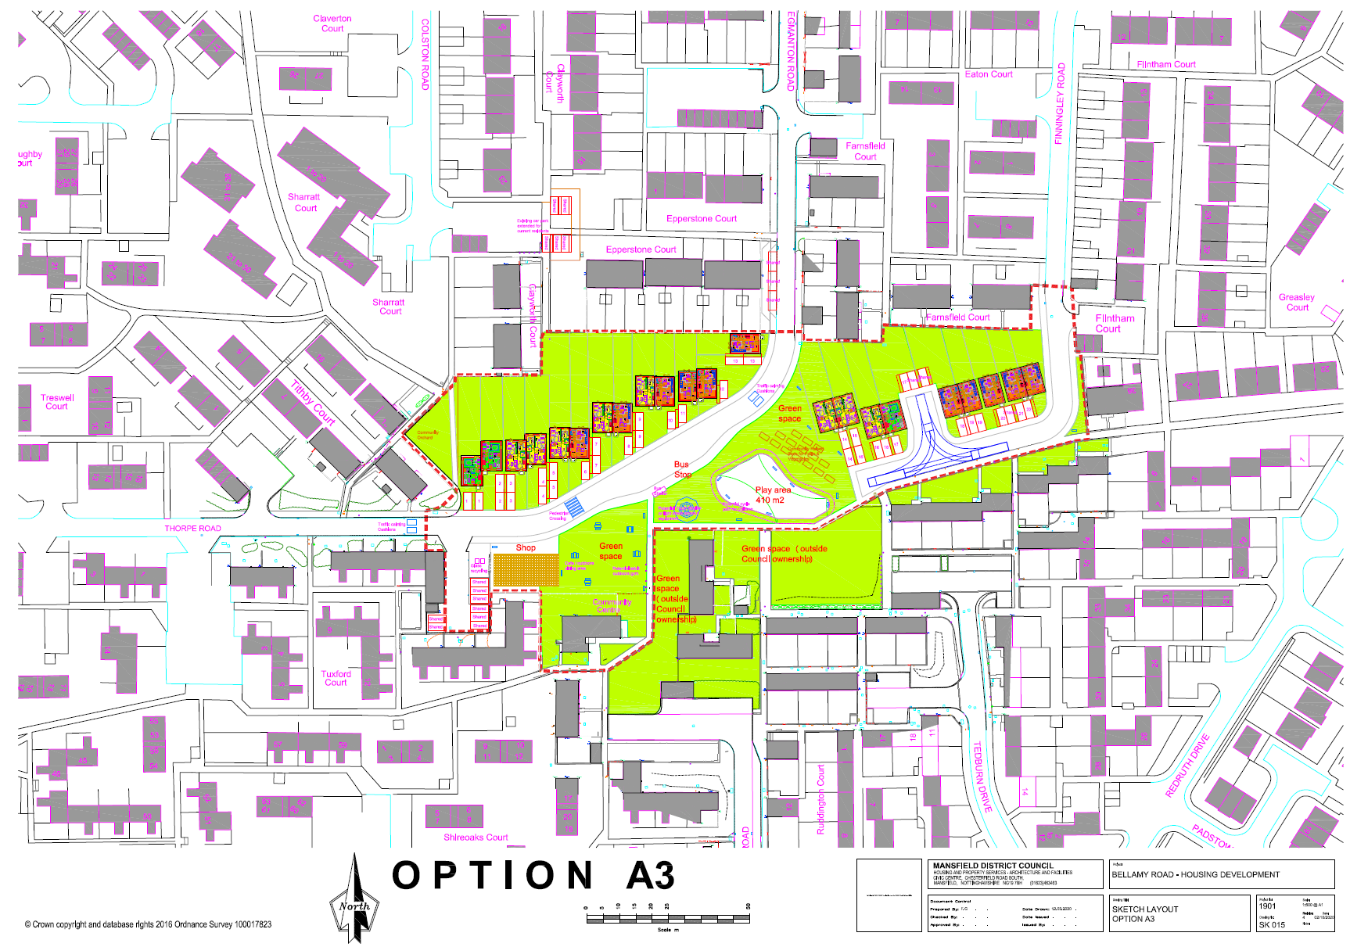
Appendix 2 – Long Term Cashflow

